East Sussex County Council Report – December 22
From Cllr Bob Bowdler
(Wealden East Division:- Heathfield, Horam, Hooe, Herstmonceux, Ninfield, Warbleton & Wartling parishes)

Communities, Economy and Transport

Historic proclamation document to be displayed in County Hall

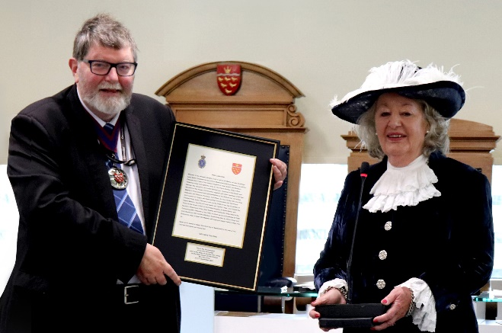
On the 6th of December, the High Sheriff of East Sussex presented a framed version of the proclamation of King Charles III to the Chairman of East Sussex County Council, Councillor Peter Pragnell. The proclamation was presented at the start of Full Council, and will go on display at County Hall.

The proclamation contains the words which were read from the steps of County Hall in September to proclaim the new King after the death of Queen Elizabeth II. The High Sheriff, Jane King, said she wanted to present the gift as ‘a reminder and souvenir of that very momentous day’. The council plans to display the document in a place which will allow as many people as possible to view it.

Environmentally-friendly gritters ready for winter in East Sussex

Gritters running on low emission biodiesel will be working to keep East Sussex moving safely this winter. Preparations are underway to ensure the 21 ‘green’ gritters are ready for snow forecasts or when the road surface temperature falls near to or below freezing.

The vehicles and their drivers were recently tested during Operation Snowdrop, an annual event which allows the gritters to be thoroughly checked and sent on trial runs of the county’s gritting routes. In addition to the gritters, the Highways team has over 9,500 tonnes of salt stored in four depots across the county, with 766 grit bins countywide refilled over the summer for use on public roads and footpaths.

Over the winter, the gritters will treat all A and B roads along with some C roads – a total of 42 per cent of roads across the county, with over 1,252km of roads treated on a primary route gritting run. .

Any problems on the roads can be reported online here.

School closure updates can be found here, and other information concerning disruption to council services can be found on the East Sussex news page.

Refurbishment projects announced for three libraries

Improvements to three East Sussex libraries mean that customers will find it even easier to access services. Work will take place in Rye, Newhaven and Hollington to improve their layout to enhance customer experience, with children’s areas and study spaces being upgraded and new seating installed. The improvements will support the library service to deliver its aims, including improving child and adult numeracy and literacy.

The schemes will also help to reduce the libraries’ carbon footprints with a range of improvements to the buildings themselves. Work at Rye Library began last month with a new children’s library planned, new furniture, an improved layout and more flexibility for customers to stay, enjoy and study within the space.

Extensive refurbishment work will begin at Hollington Library later in the spring, with a range of works being undertaken to update the building. Details of any closures will be advertised in libraries and online as soon as they have been confirmed.

Apprenticeship training funding boost

Funding to cover the full training costs of an apprenticeship is being made available to small and medium sized enterprises (SMEs) across the county. Through the council’s Apprenticeship Levy transfer scheme, the Transform programme is offering small and medium businesses in East Sussex the chance to apply for a share of over £300,000.

The Transform project aims to help SMEs in East Sussex access apprenticeship advice and funding and is part-funded by the European Social Fund and led by East Sussex County Council. It is delivered by the Sussex Council of Training Providers (SCTP).

Apprenticeships offer an opportunity for people to take the first steps onto the career ladder, change career paths or develop new skills in a current role, earn money while training and gain qualifications from entry level to the equivalent of a master’s degree. Several local businesses have already benefitted from the advice and support offered by SCTP’s Transform Skills Advisers.

Small and medium enterprises in East Sussex that would like support accessing apprenticeships and apprenticeship funding should contact transform@sctp.org.uk for further information.

Businesses can also visit the Sussex Council of Training Providers website to access the free and impartial Transform skills support service at www.sctp.org.uk/transform-programme.

For your information: Meetings I attended in December as your County Councillor:

ESCC 4 x Weekly DCS/ADCS Briefings
South East Reserve Forces & Cadets Association, Brighton
South East LM & DCS Network
Political Group Meeting
Mens Mental Health
ESCC Christmas Party for Foster Children, Eastbourne
ESCC/WSCC/Surrey CC LM Triad Challenge
ESCC Full Council
ESCC Safer Communities Board
Horam Parish Council
Hooe Parish Council. DNA
Horam Parish Council SLR Meeting
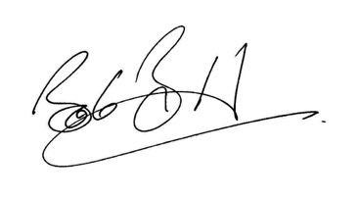
ESCC Forces Connect Member Oversight Committee
ESCC LM Education & SEND
Buzz Active, HailshamWarbleton Parish Council DNA
ESCC Cabinet
East Sussex Armed Forces Champions (Chair)
ESCC Youth Service
ESCC People Scrutiny Committee Wealden East Division
24/12/22

